Middleware
# Source: Chatgpt (GPT-5-Mini) at [1/16/2026]
Middleware is software that acts as a bridge between different applications, systems, or services to help them communicate and manage data. It sits in the middle of two systems and facilitates their interaction, often handling tasks like:
- Data exchange
- Authentication and authorization
- Message routing
- API management
- Logging and monitoring
- Session management

Examples of Middleware:
# Source: Chatgpt (GPT-5-Mini) at [1/16/2026]
- Web servers (e.g., Apache, Nginx)
- Application servers (e.g., Tomcat, JBoss)
- Message brokers (e.g., RabbitMQ, Kafka)
- Database middleware
- Authentication middleware in web apps (like Express middleware in Node.js)

Why use Middleware?
# Source: Chatgpt (GPT-5-Mini) at [1/16/2026]
- Simplifies communication between different systems or components.
- Helps standardize and manage processes.
- Allows developers to add functionality without modifying the core application.

Example
# Source: Chatgpt (GPT-5-Mini) at [1/16/2026]
Sure! Here’s a simple example of middleware in a web development context using Node.js with the Express framework:
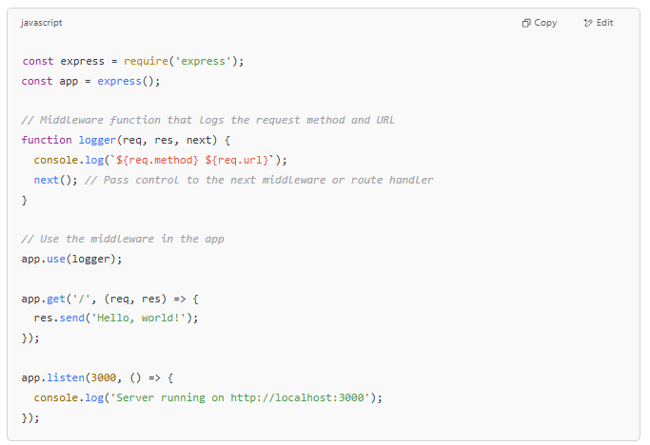
const express = require('express');
const app = express();

// Middleware function that logs the request method and URL
function logger(req, res, next) {
console.log(`${req.method} ${req.url}`);
next(); // Pass control to the next middleware or route handler
}

// Use the middleware in the app
app.use(logger);

app.get('/', (req, res) => {
res.send('Hello, world!');
});

app.listen(3000, () => {
console.log('Server running on http://localhost:3000');
});

Explanation:
- The logger function is middleware.
- It runs before the route handler.
- It logs every request’s HTTP method and URL.
- The next() function lets Express know to continue processing the request.
Would you like an example in another programming language or context?

middleware in laravel
# Source: Chatgpt (GPT-5-Mini) at [1/16/2026]
In Laravel, middleware is a mechanism that filters HTTP requests entering your application. It sits between the request and the application logic, allowing you to inspect, modify, or reject requests before they reach your routes or controllers.

What middleware does in Laravel:
# Source: Chatgpt (GPT-5-Mini) at [1/16/2026]
- Authenticate users (check if a user is logged in)
- Log requests
- Modify request or response data
- Handle CORS (Cross-Origin Resource Sharing)
- Throttle requests to prevent abuse
- Redirect users based on roles or permissions

How middleware works in Laravel:
# Source: Chatgpt (GPT-5-Mini) at [1/16/2026]
When a request comes in, Laravel runs it through a stack of middleware. Each middleware can perform an action and then either pass the request along or stop it.

Simple example of middleware in Laravel:
# Source: Chatgpt (GPT-5-Mini) at [1/16/2026]
<?php

namespace App\Http\Middleware;

use Closure;
use Illuminate\Http\Request;

class CheckAge
{
public function handle(Request $request, Closure $next)
{
if ($request->age <= 18) {
return redirect('home');
}

return $next($request); // Pass request to next middleware or controller
}
}

This example middleware checks if the user’s age is over 18. If not, it redirects them to the home page.

How to apply middleware:
# Source: Chatgpt (GPT-5-Mini) at [1/16/2026]
You can assign middleware to routes in your routes/web.php file:
Route::get('/profile', function () {
// Only accessible if age > 18
})->middleware('check.age');

